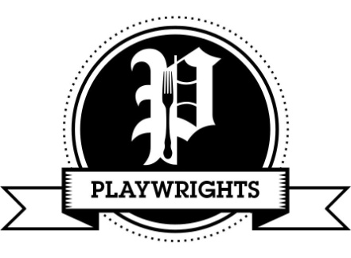
Vegan Menu

To Start
Chef’s soup of the day- warm crusty bread (gfo) £4.50
Bread & olives- warm crusty bread, marinated olives, olive oil & balsamic (gfo) £4.95
Beetroot & ‘goats cheese’ tart- on dressed balsamic mixed leaves (gf) £5.75
Mushroom & roasted garlic pate- red onion jam & toast (gfo) £4.95
Spicy breaded bean balls- salad & sweet chilli sauce (gf) £5.75
Sharing board- olives, falafels, pickled cabbage & cucumber, hummus & toasted flatbread (gfo) £8.95

Mains
The Playwrights’ Mushroom Plate- roasted garlic & rosemary Portobello mushrooms, roasted tomato, onion rings & chunky chips (gf) £8.95
Butternut squash & peppers in a creamy sauce- puff pastry crust, lemon & herb crushed new potatoes & charred broccoli (gfo) £8.95
Sundried tomato & basil risotto- toasted ciabatta (gfo) £8.95
Spiced bean burger- with cheese & sweet chilli in a toasted bun, skinny fries & pickled cabbage (gf) £8.95
Cauliflower, chickpea & coconut curry- with basmati rice & flatbread (gfo) £9.95
Falafel & hummus house salad- on a dressed mixed salad (gf) £7.50
Roasted olive & tomato linguini- garlic baguette (gfo) £7.95
Fajita sizzler- seasoned pan fried vegetables on a sizzling iron skillet, tortilla wraps, salad, salsa & cheese (gfo) £9.95
Bangers & Mash- rosemary & red onion sausages, creamy mashed potato, Savoy cabbage, onion gravy (gf) £7.95

Sides - (gf) £2.50
Garlic baguette, skinny fries, chunky chips, salad, Savoy cabbage, pickled cabbage

