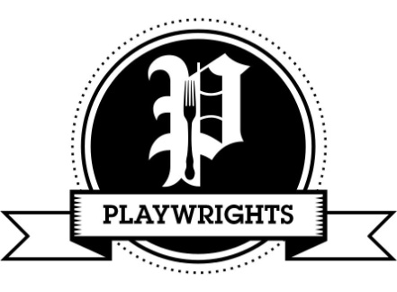

Christmas Day Menu

Glass of fizz on arrival

***

Starters

Carrot & parsnip soup, root vegetable crisps & crusty roll (vgo/dfo/gfo)
Coquille St. Jaques- scallops in a creamy white wine sauce with piped potato & Parmesan (gfo)
Duck, orange & Cognac pâté, dressed leaves, red onion chutney, granary toast (gfo)
Wild mushroom & cranberry crostini, balsamic syrup (vg/gfo)

Mains

Roasted Norfolk turkey breast, stuffing, pigs in blankets, pan gravy (gfo/dfo)
Classic beef Wellington, red wine & mushroom sauce (dfo)
Braised lamb shank, red wine & mint pan gravy (gf/df)
Grilled Seabass fillets with salsa verde & pea shoots (gf/dfo)
Vegetable & lentil Wellington with a rich vegetable gravy (vg/df/gfo)

All served with roast potatoes, roast chantenay carrots & parsnips, buttered Brussels sprouts & braised red cabbage

Sides

Pigs in blankets £2.00, cauliflower cheese £3.00, mashed potato £2.00, Yorkshire pudding £1.25, stuffing £1.25

Desserts

Traditional Christmas pudding, brandy sauce (gfo/vgo/dfo)
White chocolate & forest fruit Eton mess (gf/dfo)
Orange & cinnamon cheesecake (gfo/vgo)
British cheese & biscuit selection (vgo/dfo/gfo)

***

Coffee & mince pie to finish

£65.00 per person, booking essential

02476231441 playwrights@live.co.uk

